import numpy as np

import matplotlib.pyplot as plt

import random

from keras.datasets import mnist

from keras.models import Sequential

from keras.layers.core import Dense, Dropout, Activation

from keras.utils import np_utils

**Load the MNIST dataset**

In [ ]:

(X_train, y_train), (X_test, y_test) = mnist.load_data()

print("X_train shape", X_train.shape)

print("y_train shape", y_train.shape)

print("X_test shape", X_test.shape)

print("y_test shape", y_test.shape)

X_train shape (60000, 28, 28)

y_train shape (60000,)

X_test shape (10000, 28, 28)

y_test shape (10000,)

for i in range(9):

plt.subplot(3,3,i+1)

num = random.randint(0, len(X_train))

plt.imshow(X_train[num], cmap='gray', interpolation='none')

plt.title("Class {}".format(y_train[num]))

plt.tight_layout()

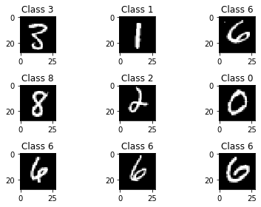

X_train = X_train.reshape(60000, 784)

X_test = X_test.reshape(10000, 784)

X_train = X_train.astype('float32')

X_test = X_test.astype('float32')

X_train /= 255

X_test /= 255

print("Training matrix shape", X_train.shape)

print("Testing matrix shape", X_test.shape)

Training matrix shape (60000, 784)

Testing matrix shape (10000, 784)

no_classes = 10

Y_train = np_utils.to_categorical(y_train, no_classes)

Y_test = np_utils.to_categorical(y_test, no_classes)

model = Sequential()

model.add(Dense(512, input_shape=(784,)))

model.add(Activation('relu'))

model.add(Dropout(0.2))

model.add(Dense(512))

model.add(Activation('relu'))

model.add(Dropout(0.2))

model.add(Dense(10))

model.add(Activation('softmax'))

model.summary()

Model: "sequential_3"

_________________________________________________________________

Layer (type) Output Shape Param #

=================================================================

dense_7 (Dense) (None, 512) 401920

_________________________________________________________________

activation_7 (Activation) (None, 512) 0

_________________________________________________________________

dropout_5 (Dropout) (None, 512) 0

_________________________________________________________________

dense_8 (Dense) (None, 512) 262656

_________________________________________________________________

activation_8 (Activation) (None, 512) 0

_________________________________________________________________

dropout_6 (Dropout) (None, 512) 0

_________________________________________________________________

dense_9 (Dense) (None, 10) 5130

_________________________________________________________________

activation_9 (Activation) (None, 10) 0

=================================================================

Total params: 669,706

Trainable params: 669,706

Non-trainable params: 0

_________________________________________________________________

model.compile(loss='categorical_crossentropy', optimizer='adam', metrics=['accuracy'])

history = model.fit(X_train, Y_train,

batch_size=128, epochs=5,

verbose=1)

Epoch 1/5

60000/60000 [==============================] - 9s 147us/step - loss: 0.2493 - accuracy: 0.9250

Epoch 2/5

60000/60000 [==============================] - 9s 147us/step - loss: 0.1000 - accuracy: 0.9686

Epoch 3/5

60000/60000 [==============================] - 9s 146us/step - loss: 0.0723 - accuracy: 0.9773

Epoch 4/5

60000/60000 [==============================] - 9s 147us/step - loss: 0.0560 - accuracy: 0.9821

Epoch 5/5

60000/60000 [==============================] - 9s 147us/step - loss: 0.0454 - accuracy: 0.9849

score = model.evaluate(X_test, Y_test)

print('Test score:', score[0])

print('Test accuracy:', score[1])

10000/10000 [==============================] - 1s 67us/step

Test score: 0.06385218842983595

Test accuracy: 0.9812999963760376

import os

save_dir = "/"

model_name = 'keras_mnist.h5'

model_path = os.path.join(save_dir, model_name)

model.save(model_path)

print('Saved trained model at %s ' % model_path)

Saved trained model at /keras_mnist.h5

fig = plt.figure()

plt.subplot(2,1,1)

plt.plot(history.history['accuracy'])

plt.title('model accuracy')

plt.ylabel('accuracy')

plt.xlabel('epoch')

plt.legend(['train', 'test'], loc='lower right')

plt.subplot(2,1,2)

plt.plot(history.history['loss'])

plt.title('model loss')

plt.ylabel('loss')

plt.xlabel('epoch')

plt.legend(['train', 'test'], loc='upper right')

plt.tight_layout()

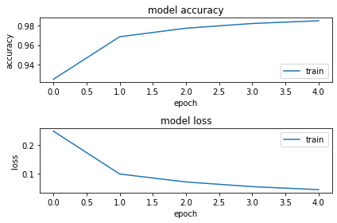

predicted_classes = model.predict_classes(X_test)

correct_indices = np.nonzero(predicted_classes == y_test)[0]

incorrect_indices = np.nonzero(predicted_classes != y_test)[0]

In [ ]:

plt.figure()

for i, correct in enumerate(correct_indices[:9]):

plt.subplot(3,3,i+1)

plt.imshow(X_test[correct].reshape(28,28), cmap='gray', interpolation='none')

plt.title("Predicted {}, Class {}".format(predicted_classes[correct], y_test[correct]))

plt.tight_layout()

plt.figure()

for i, incorrect in enumerate(incorrect_indices[:9]):

plt.subplot(3,3,i+1)

plt.imshow(X_test[incorrect].reshape(28,28), cmap='gray', interpolation='none')

plt.title("Predicted {}, Class {}".format(predicted_classes[incorrect], y_test[incorrect]))

plt.tight_layout()

